Assignment no 4- byusing scm poll

3 repository 3job 3index.html files 1in each repo is de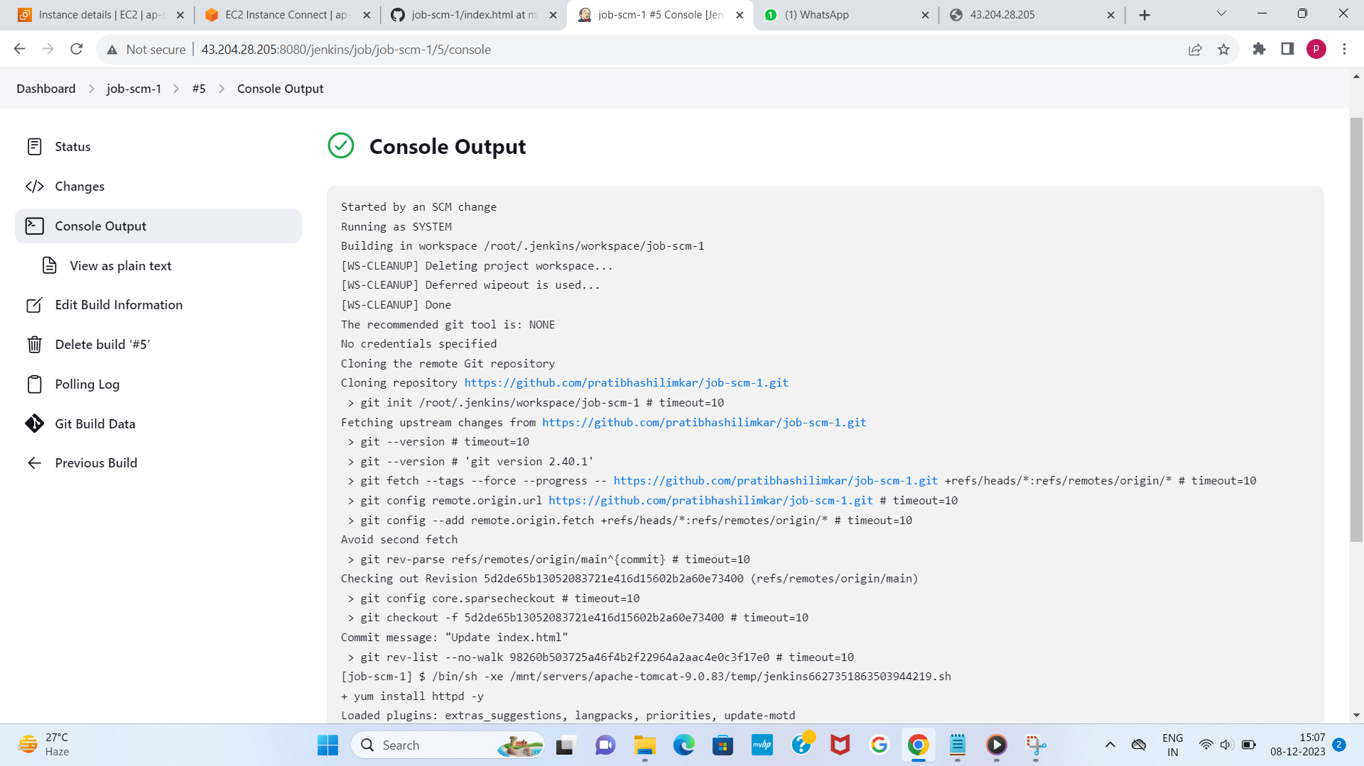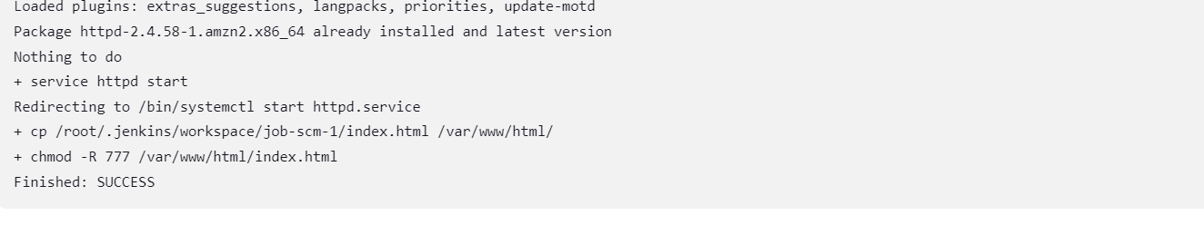



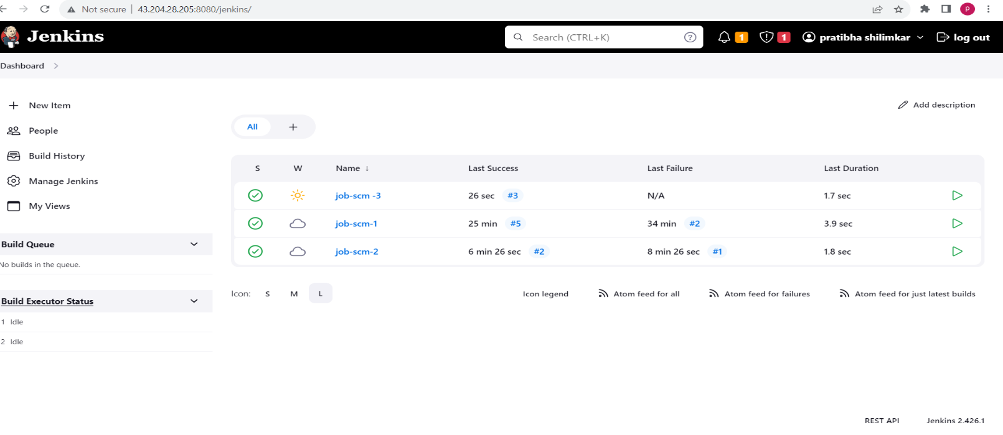 ALL THREE JOBS BUILD SUCCESSFULLY